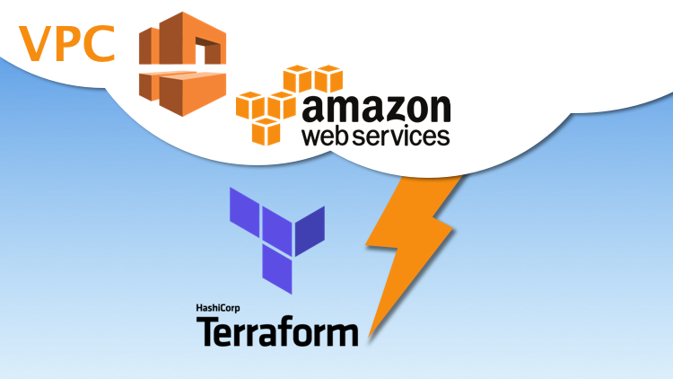

Terraform AWS VPC

1. Creating Only VPC

vi test1.tf

provider "aws" {

profile = "default"

region = "ap-south-1"

}

resource "aws_vpc" "vpc-1" {

cidr_block = "10.100.0.0/16"

instance_tenancy = "default"

tags = {

Name = "Mumbai-vpc1"

}

}

1. Creating VPC and Internet Gateway and attaching it.

vi test2.tf

provider "aws" {

profile = "default"

region = "ap-south-1"

}

resource "aws_vpc" "vpc-1" {

cidr_block = "10.100.0.0/16"

instance_tenancy = "default"

tags = {

Name = "Mumbai-vpc1"

}

}

resource "aws_internet_gateway" "my-ig-1" {

vpc_id = aws_vpc.vpc-1.id

tags = {

Name = "my-internetgateway1"

}

}

1. Create VPC , Public Subnet, Private Subnet and Internet Gateway –And Attach IG to VPC

vi test3.tf

provider "aws" {

profile = "default"

region = "ap-south-1"

}

resource "aws_vpc" "vpc-1" {

cidr_block = "10.100.0.0/16"

instance_tenancy = "default"

tags = {

Name = "Mumbai-vpc1"

}

}

resource "aws_internet_gateway" "my-ig-1" {

vpc_id = aws_vpc.vpc-1.id

tags = {

Name = "my-internetgateway1"

}

}

resource "aws_subnet" "public_subnet" {

vpc_id = aws_vpc.vpc-1.id

cidr_block = "10.100.1.0/24"

availability_zone = "ap-south-1a"

tags = {

Name = "mumbai-vpc-public-subnet"

Environment = "Dev"

}

}

resource "aws_subnet" "private_subnet" {

vpc_id = aws_vpc.vpc-1.id

cidr_block = "10.100.2.0/24"

availability_zone = "ap-south-1b"

tags = {

Name = "mumbai-vpc-private-subnet"

Environment = "Dev"

}

}

1. Create VPC , Public Subnet, Private Subnet, Route table and Internet Gateway –And Attach IG to VPC --------------------Full VPC Setup

# vi test4.tf

/*==== Provider======*/

provider "aws" {

profile = "default"

region = "ap-south-1"

}

/*==== The VPC ======*/

resource "aws_vpc" "vpc-1" {

cidr_block = "10.100.0.0/16"

instance_tenancy = "default"

tags = {

Name = "Mumbai-vpc1"

}

}

/*==== Internet gateway ======*/

resource "aws_internet_gateway" "my-ig-1" {

vpc_id = aws_vpc.vpc-1.id

tags = {

Name = "my-internetgateway1"

}

}

/*==== Public Subnet ======*/

resource "aws_subnet" "public_subnet" {

vpc_id = aws_vpc.vpc-1.id

cidr_block = "10.100.1.0/24"

availability_zone = "ap-south-1a"

tags = {

Name = "mumbai-vpc1-public-subnet"

Environment = "Dev"

}

}

/*==== Private Subnet ======*/

resource "aws_subnet" "private_subnet" {

vpc_id = aws_vpc.vpc-1.id

cidr_block = "10.100.2.0/24"

availability_zone = "ap-south-1b"

tags = {

Name = "mumbai-vpc1-private-subnet"

Environment = "Dev"

}

}

/*==== Route table ======*/

resource "aws_route_table" "public" {

vpc_id = aws_vpc.vpc-1.id

tags = {

Name = "mumbai-vpc1-public-route-table"

}

}

/*==== Adding routes to Route Table ======*/

resource "aws_route" "public_internet_gateway" {

route_table_id = aws_route_table.public.id

destination_cidr_block = "0.0.0.0/0"

gateway_id = aws_internet_gateway.my-ig-1.id

}

/*===== Route table associations========== */

resource "aws_route_table_association" "public" {

subnet_id = aws_subnet.public_subnet.id

route_table_id = aws_route_table.public.id

}